1-On-Premises Infrastructure

🏢 What Is On-Premises Infrastructure?
# Source: AI Source: Provided by: [Data Path: Persons Table -> ID Column: 1, Name_En Column: Motasem Essam] -> From: [Chatgpt (GPT‑5 Mini)] on [1/14/2026]
On-premises infrastructure (or on-prem) refers to IT hardware and software resources that are physically located and managed within an organization’s own facilities, rather than being hosted by a third-party provider like a cloud service.

🧠 Simple Definition:
# Source: AI Source: Provided by: [Data Path: Persons Table -> ID Column: 1, Name_En Column: Motasem Essam] -> From: [Chatgpt (GPT‑5 Mini)] on [1/14/2026]
On-premises infrastructure means your servers, networking equipment, storage, and software are owned, installed, and maintained on your company's site (in a data center or server room).

🧰 Components of On-Premises Infrastructure
# Source: AI Source: Provided by: [Data Path: Persons Table -> ID Column: 1, Name_En Column: Motasem Essam] -> From: [Chatgpt (GPT‑5 Mini)] on [1/14/2026]
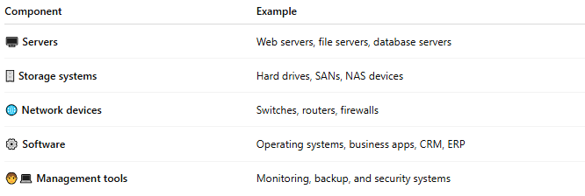
Component | Example
🖥️ Servers | Web servers, file servers, database servers
🗄️ Storage systems | Hard drives, SANs, NAS devices
🌐 Network devices | Switches, routers, firewalls
⚙️ Software | Operating systems, business apps, CRM, ERP
🧑‍💻 Management tools | Monitoring, backup, and security systems

🔒 Key Characteristics
# Source: AI Source: Provided by: [Data Path: Persons Table -> ID Column: 1, Name_En Column: Motasem Essam] -> From: [Chatgpt (GPT‑5 Mini)] on [1/14/2026]
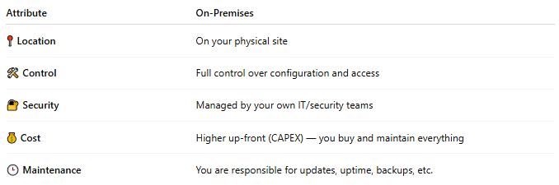
Attribute | On-Premises
📍 Location | On your physical site
🛠 Control | Full control over configuration and access
🔐 Security | Managed by your own IT/security teams
💰 Cost | Higher up-front (CAPEX) — you buy and maintain everything
🕒 Maintenance | You are responsible for updates, uptime, backups, etc.

📦 Benefits
# Source: AI Source: Provided by: [Data Path: Persons Table -> ID Column: 1, Name_En Column: Motasem Essam] -> From: [Chatgpt (GPT‑5 Mini)] on [1/14/2026]
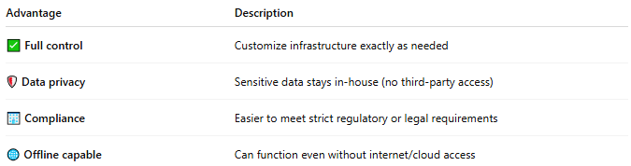
Advantage | Description
✅ Full control | Customize infrastructure exactly as needed
🛡 Data privacy | Sensitive data stays in-house (no third-party access)
🏢 Compliance | Easier to meet strict regulatory or legal requirements
🌐 Offline capable | Can function even without internet/cloud access

⚠️ Challenges
# Source: AI Source: Provided by: [Data Path: Persons Table -> ID Column: 1, Name_En Column: Motasem Essam] -> From: [Chatgpt (GPT‑5 Mini)] on [1/14/2026]
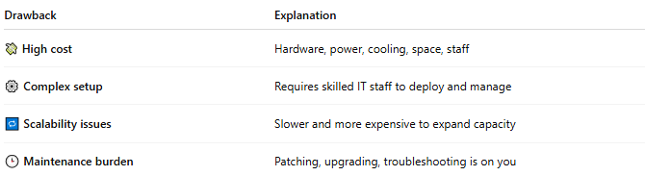
Drawback | Explanation
💸 High cost | Hardware, power, cooling, space, staff
⚙️ Complex setup | Requires skilled IT staff to deploy and manage
🔁 Scalability issues | Slower and more expensive to expand capacity
🕒 Maintenance burden | Patching, upgrading, troubleshooting is on you

🆚 On-Prem vs Cloud (Quick Comparison)
# Source: AI Source: Provided by: [Data Path: Persons Table -> ID Column: 1, Name_En Column: Motasem Essam] -> From: [Chatgpt (GPT‑5 Mini)] on [1/14/2026]
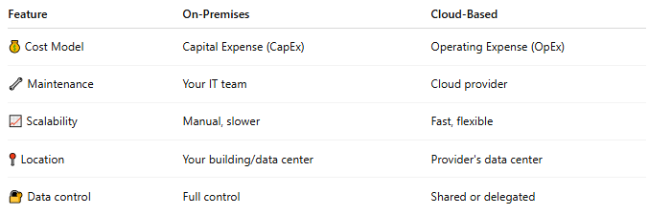
Feature | On-Premises | Cloud-Based
💰 Cost Model | Capital Expense (CapEx) | Operating Expense (OpEx)
🔧 Maintenance | Your IT team | Cloud provider
📈 Scalability | Manual, slower | Fast, flexible
📍 Location | Your building/data center | Provider's data center
🔐 Data control | Full control | Shared or delegated

📌 Summary
# Source: AI Source: Provided by: [Data Path: Persons Table -> ID Column: 1, Name_En Column: Motasem Essam] -> From: [Chatgpt (GPT‑5 Mini)] on [1/14/2026]
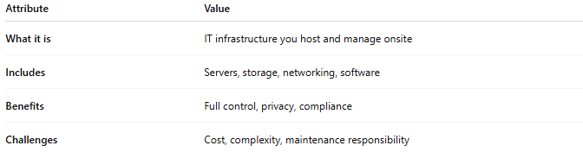
Attribute | Value
What it is | IT infrastructure you host and manage onsite
Includes | Servers, storage, networking, software
Benefits | Full control, privacy, compliance
Challenges | Cost, complexity, maintenance responsibility

2-Cloud Infrastructure

☁️ What Is Cloud Infrastructure?
# Source: AI Source: Provided by: [Data Path: Persons Table -> ID Column: 1, Name_En Column: Motasem Essam] -> From: [Chatgpt (GPT‑5 Mini)] on [1/14/2026]
Cloud infrastructure refers to the virtualized computing resources—such as servers, storage, networking, and software—that are delivered over the internet by a cloud provider. Instead of owning and maintaining physical hardware, users access resources on-demand from a cloud data center.

🧠 Simple Definition:
# Source: AI Source: Provided by: [Data Path: Persons Table -> ID Column: 1, Name_En Column: Motasem Essam] -> From: [Chatgpt (GPT‑5 Mini)] on [1/14/2026]
Cloud infrastructure is a virtual IT environment provided by a third party (like AWS, Azure, or Google Cloud), where users can run applications, store data, and scale services without owning physical hardware.

🧰 Core Components of Cloud Infrastructure
# Source: AI Source: Provided by: [Data Path: Persons Table -> ID Column: 1, Name_En Column: Motasem Essam] -> From: [Chatgpt (GPT‑5 Mini)] on [1/14/2026]
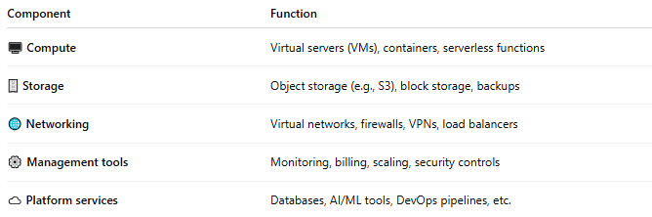

Component | Function
🖥️ Compute | Virtual servers (VMs), containers, serverless functions
🗄️ Storage | Object storage (e.g., S3), block storage, backups
🌐 Networking | Virtual networks, firewalls, VPNs, load balancers
⚙️ Management tools | Monitoring, billing, scaling, security controls
☁️ Platform services | Databases, AI/ML tools, DevOps pipelines, etc.

☁️ Cloud Infrastructure Types
# Source: AI Source: Provided by: [Data Path: Persons Table -> ID Column: 1, Name_En Column: Motasem Essam] -> From: [Chatgpt (GPT‑5 Mini)] on [1/14/2026]
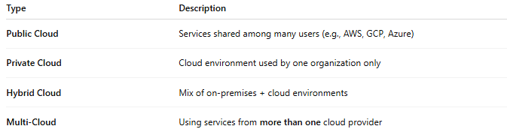

Type | Description
Public Cloud | Services shared among many users (e.g., AWS, GCP, Azure)
Private Cloud | Cloud environment used by one organization only
Hybrid Cloud | Mix of on-premises + cloud environments
Multi-Cloud | Using services from more than one cloud provider

📦 Examples of Cloud Providers
# Source: AI Source: Provided by: [Data Path: Persons Table -> ID Column: 1, Name_En Column: Motasem Essam] -> From: [Chatgpt (GPT‑5 Mini)] on [1/14/2026]
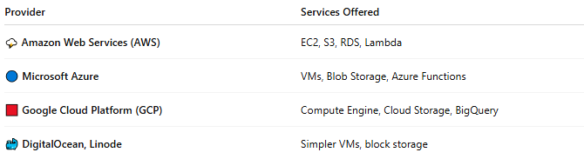

Provider | Services Offered
🌩️ Amazon Web Services (AWS) | EC2, S3, RDS, Lambda
🔵 Microsoft Azure | VMs, Blob Storage, Azure Functions
🟥 Google Cloud Platform (GCP) | Compute Engine, Cloud Storage, BigQuery
🐳 DigitalOcean, Linode | Simpler VMs, block storage

✅ Benefits of Cloud Infrastructure
# Source: AI Source: Provided by: [Data Path: Persons Table -> ID Column: 1, Name_En Column: Motasem Essam] -> From: [Chatgpt (GPT‑5 Mini)] on [1/14/2026]
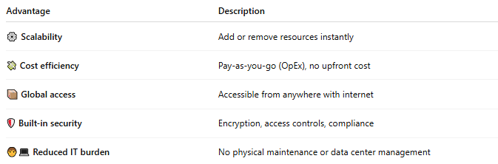

Advantage | Description
⚙️ Scalability | Add or remove resources instantly
💸 Cost efficiency | Pay-as-you-go (OpEx), no upfront cost
📦 Global access | Accessible from anywhere with internet
🛡️ Built-in security | Encryption, access controls, compliance
🧑‍💻 Reduced IT burden | No physical maintenance or data center management

⚠️ Challenges to Consider
# Source: AI Source: Provided by: [Data Path: Persons Table -> ID Column: 1, Name_En Column: Motasem Essam] -> From: [Chatgpt (GPT‑5 Mini)] on [1/14/2026]
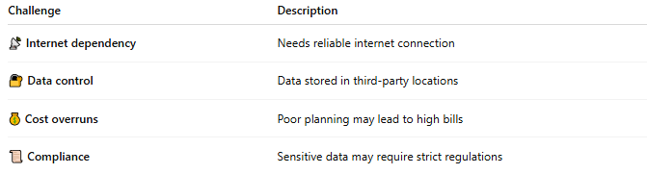

Challenge | Description
📡 Internet dependency | Needs reliable internet connection
🔐 Data control | Data stored in third-party locations
💰 Cost overruns | Poor planning may lead to high bills
📜 Compliance | Sensitive data may require strict regulations

🆚 On-Premises vs Cloud Infrastructure
# Source: AI Source: Provided by: [Data Path: Persons Table -> ID Column: 1, Name_En Column: Motasem Essam] -> From: [Chatgpt (GPT‑5 Mini)] on [1/14/2026]
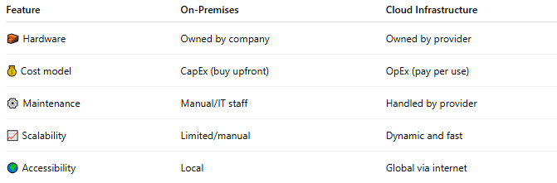

Feature | On-Premises | Cloud Infrastructure
🧱 Hardware | Owned by company | Owned by provider
💰 Cost model | CapEx (buy upfront) | OpEx (pay per use)
⚙️ Maintenance | Manual/IT staff | Handled by provider
📈 Scalability | Limited/manual | Dynamic and fast
🌍 Accessibility | Local | Global via internet

📌 Summary
# Source: AI Source: Provided by: [Data Path: Persons Table -> ID Column: 1, Name_En Column: Motasem Essam] -> From: [Chatgpt (GPT‑5 Mini)] on [1/14/2026]
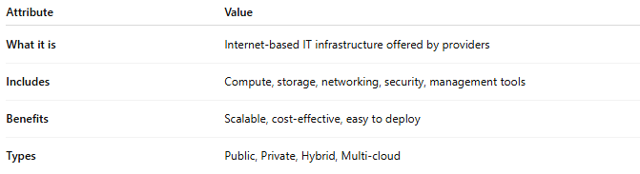

Attribute | Value
What it is | Internet-based IT infrastructure offered by providers
Includes | Compute, storage, networking, security, management tools
Benefits | Scalable, cost-effective, easy to deploy
Types | Public, Private, Hybrid, Multi-cloud

